Welcoming our Emotional Wellbeing Practitioners

What do Emotional Wellbeing Practitioners do?
Emotional Wellbeing Practitioners (EWPs) aim to improve access to mental health support for children, young people and their families. Using evidence-based principles, we provide low intensity interventions for young people experiencing common emotional wellbeing difficulties such as, low mood, anxiety and behavioural difficulties. EWPs also provide one-to-one support, run groups and workshops in educational settings for children and young people as well as parents and school staff. Most importantly, we will work together with South Borough Primary School to support children, young people and their families. We also work with school staff to help improve wellbeing across the school as a whole.

Who are the EWPs in South Borough Primary School?

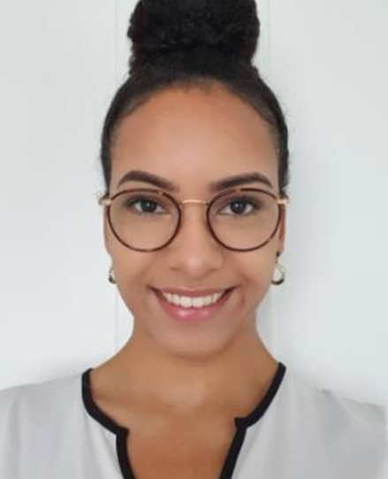
Hello I’m Sam! After graduating with a psychology degree, I gained my experience in the mental health field of work at Maidstone and Mid Kent Mind, where I developed my passion for helping to improve the emotional wellbeing of young people. This is what motivated me to take on the role of an Emotional Wellbeing Practitioner in which I could be more heavily involved with schools across Maidstone. I am very much looking forward to working with students, parents and staff at South Borough Primary School. Some of my other passions involve travelling, spending time with family and friends and music events.

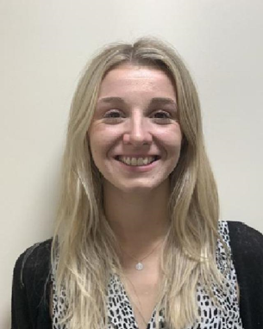
Hello! My name is Lauren and I am part of the new Emotional Wellbeing Team in South Borough Primary School. Before starting this role I have had two school-based support roles and I have completed an Undergraduate degree in Psychology and a Masters in Child and Adolescent Mental Health. I have also volunteered in various psychiatric facilities. I am looking forward to combining my skills from working in schools and my knowledge of mental health to create positive change regarding wellbeing in your school. Outside of work my hobbies include travelling and reading.

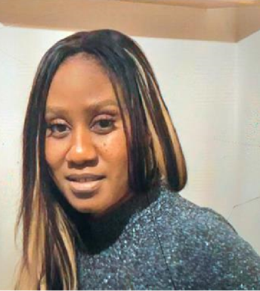
Hi, my name is Karen. I have worked with children and young people in both secondary and primary schools for over 14 years. I particularly enjoyed teaching PSHE, RE and Citizenship. My hobbies are Musical Theatre and dance. I became an EWP because I believe that looking after our emotional and mental health it is equally as important as looking after our physical health. I look forward to working with the staff, parents and young people of South Borough Primary School.

